Protocol for the Examination of Specimens From Patients With Carcinoma of the Stomach
Version: Stomach 4.0.0.0 | Protocol Posting Date: June 2017

Includes pTNM requirements from the 8th Edition, AJCC Staging Manual

For accreditation purposes, this protocol should be used for the following procedures AND tumor types:
Procedure | Description
Resection | Includes partial or complete gastrectomy
Tumor Type | Description
Carcinomas | Includes carcinomas involving the esophagogastric junction (EGJ) with tumor midpoint >2 cm into the proximal stomach and carcinomas of the cardia/proximal stomach without involvement of the EGJ even if tumor midpoint is ≤2 cm into the proximal stomach

This protocol is NOT required for accreditation purposes for the following:
Procedure
Excisional biopsy (includes endoscopic resection and polypectomy)
Primary resection specimen with no residual cancer (eg, following neoadjuvant therapy)
Recurrent tumor
Cytologic specimens

The following tumor types should NOT be reported using this protocol:
Tumor Type
Carcinoma involving the EGJ with center ≤2 cm into the proximal stomach (consider the Esophagus protocol)
Well-differentiated neuroendocrine tumor (consider the Stomach NET protocol)
Lymphoma (consider the Hodgkin or non-Hodgkin Lymphoma protocols)
Gastrointestinal stromal tumor (GIST) (consider the GIST protocol)
Non-GIST sarcoma (consider the Soft Tissue protocol)

Authors
Chanjuan Shi, MD, PhD*; Jordan Berlin, MD; Philip A. Branton, MD; Patrick L. Fitzgibbons, MD; Wendy L. Frankel, MD; Wayne L. Hofstetter, MD; Sanjay Kakar, MD; David Kelsen, MD; Veronica Klepeis, MD, PhD; Jason Talmadge Lewis, MD; Laura H. Tan, MD. PhD; Mary K. Washington, MD, PhD

With guidance from the CAP Cancer and CAP Pathology Electronic Reporting Committees.
* Denotes primary author. All other contributing authors are listed alphabetically.

Accreditation Requirements
This protocol can be utilized for a variety of procedures and tumor types for clinical care purposes. For accreditation purposes, only the definitive primary cancer resection specimen is required to have the core and conditional data elements reported in a synoptic format.
- Core data elements are required in reports to adequately describe appropriate malignancies. For accreditation purposes, essential data elements must be reported in all instances, even if the response is “not applicable” or “cannot be determined.”
- Conditional data elements are only required to be reported if applicable as delineated in the protocol. For instance, the total number of lymph nodes examined must be reported, but only if nodes are present in the specimen.
- Optional data elements are identified with “+” and although not required for CAP accreditation purposes, may be considered for reporting as determined by local practice standards.
The use of this protocol is not required for recurrent tumors or for metastatic tumors that are resected at a different time than the primary tumor. Use of this protocol is also not required for pathology reviews performed at a second institution (ie, secondary consultation, second opinion, or review of outside case at second institution).

Endoscopic resection is NOT considered to be the definitive resection specimen, even though the entire cancer may be removed. A protocol is recommended for reporting such specimens for clinical care purposes, but this is not required for accreditation purposes.

Synoptic Reporting
All core and conditionally required data elements outlined on the surgical case summary from this cancer protocol must be displayed in synoptic report format. Synoptic format is defined as:
- Data element: followed by its answer (response), outline format without the paired "Data element: Response" format is NOT considered synoptic.
- The data element must be represented in the report as it is listed in the case summary. The response for any data element may be modified from those listed in the case summary, including “Cannot be determined” if appropriate.
- Each diagnostic parameter pair (Data element: Response) is listed on a separate line or in a tabular format to achieve visual separation. The following exceptions are allowed to be listed on one line:
  - Anatomic site or specimen, laterality, and procedure
  - Pathologic Stage Classification (pTNM) elements
  - Negative margins, as long as all negative margins are specifically enumerated where applicable
- The synoptic portion of the report can appear in the diagnosis section of the pathology report, at the end of the report or in a separate section, but all Data element: Responses must be listed together in one location
Organizations and pathologists may choose to list the required elements in any order, use additional methods in order to enhance or achieve visual separation, or add optional items within the synoptic report. The report may have required elements in a summary format elsewhere in the report IN ADDITION TO but not as replacement for the synoptic report i.e. all required elements must be in the synoptic portion of the report in the format defined above.

CAP Laboratory Accreditation Program Protocol Required Use Date: March 2018*

* Beginning January 1, 2018, the 8th edition AJCC Staging Manual should be used for reporting pTNM.

CAP Stomach Protocol Summary of Changes

The following data elements were modified:
Pathologic Stage Classification (pTNM, AJCC 8th Edition)
Tumor Site
Histologic Type
Microscopic Tumor Extension
Treatment Effect

Surgical Pathology Cancer Case Summary

Protocol posting date: June 2017

STOMACH:

Select a single response unless otherwise indicated.

Procedure (Note A)
___ Endoscopic resection
___ Partial gastrectomy, proximal
___ Partial gastrectomy, distal
___ Partial gastrectomy, other (specify): ____________________________
___ Total gastrectomy
___ Other (specify): ____________________________
___ Not specified

Tumor Site (select all that apply) (Note B)
___ Cardia
___ Fundus
+ ___ Anterior wall
+ ___ Posterior wall
___ Body
+ ___ Anterior wall
+ ___ Posterior wall
+ ___ Lesser curvature
+ ___ Greater curvature
___ Antrum
+ ___ Anterior wall
+ ___ Posterior wall
+ ___ Lesser curvature
+ ___ Greater curvature
___ Pylorus
___ Other (specify): ____________________________
___ Not specified
Note: Use the esophageal cancer protocol if the tumor involves the EGJ and the tumor midpoint is 2 cm or less into the proximal stomach.

Tumor Size

Greatest dimension (centimeters): ___ cm
+ Additional dimensions (centimeters): ___ x ___ cm
___ Cannot be determined (explain): _________________________________

Histologic Type (Note C)
___ Adenocarcinoma
Lauren classification of adenocarcinoma:
___ Intestinal type
___ Diffuse type (includes signet-ring carcinoma, classified as >50% signet-ring cells)
___ Mixed (approximately equal amounts of intestinal and diffuse)
+ Alternative optional classification (based on WHO classification):
+ ___ Tubular (intestinal) adenocarcinoma
+ ___ Poorly cohesive carcinoma (including signet-ring cell carcinoma and other variants)
+ ___ Mucinous adenocarcinoma (>50% mucinous)
+ ___ Papillary adenocarcinoma
+ ___Mixed carcinoma (mixture of discrete glandular (tubular/papillary) and signet-ring/poorly cohesive cellular histological components)
___ Hepatoid adenocarcinoma
___ Carcinoma with lymphoid stroma (medullary carcinoma)
___ Large cell neuroendocrine carcinoma
___ Small cell neuroendocrine carcinoma
___ Neuroendocrine carcinoma (poorly differentiated)#
___ Mixed adenoneuroendocrine carcinoma
___ Squamous cell carcinoma
___ Adenosquamous carcinoma
___ Undifferentiated carcinoma
___ Other histologic type not listed (specify): _________________________________
# Note: Select this option only if large cell or small cell cannot be determined.

Histologic Grade (Note D)
___ G1: Well differentiated
___ G2: Moderately differentiated
___ G3: Poorly differentiated, undifferentiated
___ Other (specify): ____________________________
___ GX: Cannot be assessed
___ Not applicable

Tumor Extension
___ No evidence of primary tumor
___ Carcinoma in situ: intraepithelial tumor without invasion of the lamina propria, high-grade dysplasia
___ Tumor invades the lamina propria
___ Tumor invades the muscularis mucosae
___ Tumor invades the submucosa
___ Tumor invades the muscularis propria
___ Tumor penetrates the subserosal connective tissue without invasion of the visceral peritoneum or adjacent structures
___ Tumor invades the serosa (visceral peritoneum)
___ Tumor invades adjacent structures/organs# (specify) ____________________
___ Cannot be assessed
# The adjacent structures of the stomach include the spleen, transverse colon, liver, diaphragm, pancreas, abdominal wall, adrenal gland, kidney, small intestine, and retroperitoneum. Intramural extension to the duodenum or esophagus is not considered invasion of an adjacent structure, but is classified using the depth of the greatest invasion in any of these sites.

Margins (Note E)
Note: Use this section only if all margins are uninvolved and all margins can be assessed.
___ All margins are uninvolved by invasive carcinoma and dysplasia
Margins examined: ___________
Note: Margins may include proximal, distal, omental (radial), mucosal, deep, and others.
+ Distance of invasive carcinoma from closest margin (millimeters or centimeters): ___ mm or ___ cm
+ Specify closest margin: __________________________

Individual margin reporting required if any margins are involved or margin involvement cannot be assessed

For gastrectomy specimens only

Proximal Margin
___ Cannot be assessed___ Involved by invasive carcinoma
___ Uninvolved by invasive carcinoma
___ Uninvolved by dysplasia
___ Involved by carcinoma in situ (high-grade dysplasia)
___ Involved by low-grade dysplasia

Distal Margin
___ Cannot be assessed___ Involved by invasive carcinoma
___ Uninvolved by invasive carcinoma
___ Uninvolved by dysplasia
___ Involved by carcinoma in situ (high-grade dysplasia)
___ Involved by low-grade dysplasia

Omental (Radial) Margins
___ Cannot be assessed
___ Uninvolved by invasive carcinoma
___ Involved by invasive carcinoma
+ ___ Greater omental margin involved by invasive carcinoma
+ ___ Lesser omental margin involved by invasive carcinoma

Other Margin(s) (required only if applicable)

Specify margin(s): _______________________
___ Cannot be assessed
___ Involved by invasive carcinoma
___ Uninvolved by invasive carcinoma

For endoscopic resection specimens only

Mucosal Margin
___ Cannot be assessed
___ Involved by invasive carcinoma
___ Uninvolved by invasive carcinoma
___ Uninvolved by dysplasia
___ Involved by carcinoma in situ (high-grade dysplasia)
___ Involved by low-grade dysplasia

Deep Margin
___ Cannot be assessed
___ Uninvolved by invasive carcinoma
___ Involved by invasive carcinoma

Other Margin(s) (required only if applicable)

Specify margin(s): _______________________
___ Cannot be assessed
___ Involved by invasive carcinoma
___ Uninvolved by invasive carcinoma

Treatment Effect (Note F)
___ No known presurgical therapy
___ Present
+ ___ No viable cancer cells (complete response, score 0)
+ ___ Single cells or rare small groups of cancer cells (near complete response, score 1)
+ ___ Residual cancer with evident tumor regression, but more than single cells or rare small groups of cancer cells (partial response, score 2)
___ Absent
+ ___ Extensive residual cancer with no evident tumor regression (poor or no response, score 3)
___ Cannot be determined

Lymphovascular Invasion (Note G)
___ Not identified
___ Present
___ Cannot be determined

+ Perineural Invasion (Note H)
+ ___ Not identified
+ ___ Present
+ ___ Cannot be determined

Regional Lymph Nodes (Note I)

___ No lymph nodes submitted or found

Lymph Node Examination (required only if lymph nodes present in specimen)

Number of Lymph Nodes Involved: ____
___ Number cannot be determined (explain): ______________________

Number of Lymph Nodes Examined: ____
___ Number cannot be determined (explain): ______________________

Pathologic Stage Classification (pTNM, AJCC 8th Edition) (Note J)
Note: Reporting of pT, pN, and (when applicable) pM categories is based on information available to the pathologist at the time the report is issued. Only the applicable T, N, or M category is required for reporting; their definitions need not be included in the report. The categories (with modifiers when applicable) can be listed on 1 line or more than 1 line.

TNM Descriptors (required only if applicable) (select all that apply)
___ m (multiple primary tumors)
___ r (recurrent)
___ y (posttreatment)

Primary Tumor (pT)
___ pTX: Primary tumor cannot be assessed
___ pT0: No evidence of primary tumor
___ pTis: Carcinoma in situ: intraepithelial tumor without invasion of the lamina propria, high-grade dysplasia
___ pT1: Tumor invades the lamina propria, muscularis mucosae, or submucosa
___ pT1a: Tumor invades the lamina propria or muscularis mucosae
___ pT1b: Tumor invades the submucosa
___ pT2: Tumor invades the muscularis propria#
___ pT3: Tumor penetrates the subserosal connective tissue without invasion of the visceral peritoneum or adjacent structures##, ###
___ pT4: Tumor invades the serosa (visceral peritoneum) or adjacent structures##, ###
___ pT4a: Tumor invades the serosa (visceral peritoneum)
___ pT4b: Tumor invades adjacent structures/organs
# A tumor may penetrate the muscularis propria with extension into the gastrocolic or gastrohepatic ligaments, or into the greater or lesser omentum, without perforation of the visceral peritoneum covering these structures. In this case, the tumor is classified as T3. If there is perforation of the visceral peritoneum covering the gastric ligaments or the omentum, the tumor should be classified as T4.
## The adjacent structures of the stomach include the spleen, transverse colon, liver, diaphragm, pancreas, abdominal wall, adrenal gland, kidney, small intestine, and retroperitoneum.
### Intramural extension to the duodenum or esophagus is not considered invasion of an adjacent structure, but is classified using the depth of the greatest invasion in any of these sites.

Regional Lymph Nodes (pN)#
___ pNX: Regional lymph node(s) cannot be assessed
___ pN0: No regional lymph node metastasis
___ pN1: Metastasis in one or two regional lymph nodes
___ pN2: Metastasis in three to six regional lymph nodes
___ pN3: Metastasis in seven or more regional lymph nodes
___ pN3a: Metastasis in seven to 15 regional lymph nodes
___ pN3b: Metastasis in 16 or more regional lymph nodes
# Note: Metastatic tumor deposits in the subserosal fat adjacent to a gastric carcinoma, without evidence of residual lymph node tissue, are considered regional lymph node metastases for purposes of gastric cancer staging.

Distant Metastasis (pM) (required only if confirmed pathologically in this case)
___ pM1: Distant metastasis
Specify site(s), if known: __________________________

+ Additional Pathologic Findings (select all that apply) (Note K)
+ ___ None identified
+ ___ Intestinal metaplasia
+ ___ Low-grade dysplasia
+ ___ High-grade dysplasia
+ ___ Helicobacter pylori-type gastritis
+ ___ Autoimmune atrophic chronic gastritis

+ ___ Polyp(s) (type[s]): ____________________________
+ ___ Other (specify): ____________________________

+ Ancillary Studies
Note: For HER2 reporting, the CAP Gastric HER2 template should be used. Pending biomarker studies should be listed in the Comments section of this report.

+ Comment(s)

Explanatory Notes

A. Application
This protocol applies to all carcinomas that arise in the stomach, including:
- Carcinomas involving the esophagogastric junction (EGJ) with tumor midpoint >2 cm into the proximal stomach
- Carcinomas of the cardia/proximal stomach without involvement of the EGJ even if tumor midpoint is ≤2 cm into the proximal stomach
This protocol DOES NOT apply to:
- Carcinomas involves the EGJ with tumor midpoint ≤2 into the proximal stomach (use CAP protocol for esophageal cancer)
- Well-differentiated neuroendocrine tumors (use CAP protocol for neuroendocrine tumors of the stomach)
- Lymphomas, gastrointestinal stromal tumors, and sarcomas.

B. Tumor Site
Tumor location should be described in relation to the following landmarks (Figure 1):
• gastric region: cardia, fundus, body, antrum, pylorus
• greater curvature, lesser curvature
• anterior wall, posterior wall

Figure 1. Anatomical subsites of the stomach. Used with permission of the American Joint Committee on Cancer (AJCC), Chicago, Illinois. The original and primary source for this information is the AJCC Cancer Staging Manual, Eighth Edition (2017) published by Springer Science+Business Media.

Tumors involving the EGJ with epicenter ≤ 2cm into the proximal stomach are classified for purposes of staging as esophageal carcinomas,¹ and the CAP protocol for the esophagus should be used for such tumors. Tumors involving the EGJ with epicenter >2 cm into the proximal stomach and any tumors in the stomach, including cardia cancers, without involvement of the EGJ should use the CAP protocol for the stomach.

The proximal stomach located immediately below the diaphragm is cardia. The remaining portions are the fundus and the body. The distal portion of the stomach is the antrum. The pylorus is composed of muscular ring and a connection between the antrum and the first portion of the duodenum. The medial curvature of the stomach is the lesser curvature, whereas the lateral curvature is the greater curvature. The EGJ is defined as the junction of the tubular esophagus and the stomach irrespective of the type of epithelial lining of the esophagus.

C. Histologic Type
For consistency in reporting, the recently revised histologic classification proposed by the WHO is recommended² (Table 1) but not required for clinical use. However, this classification scheme does not distinguish between intestinal and diffuse types of gastric carcinoma but includes signet-ring cell carcinoma in the poorly cohesive carcinoma category. Thus, the Laurén classification⁴ may be used in conjunction with the WHO system.

With the exception of the rare small cell carcinoma of the stomach, which has an unfavorable prognosis, most multivariate analyses show no effect of tumor type, independent of stage, on prognosis.³

Table 1. WHO Classification of Carcinoma of the Stomach²
Tumor Type | Histologic Features
Adenocarcinoma  Papillary adenocarcinoma  Tubular adenocarcinoma  Mucinous adenocarcinoma  Poorly cohesive carcinomas, including signet-ring cell carcinoma and other variants  Mixed carcinoma | Exophytic with elongated frond-like tumor extensions with fibrovascular cores; usually low grade.  Dilated or slit-like branching tubules; usually low grade, although poorly differentiated variants are described.  Contains more than 50% extracellular mucin pools. May contain scattered signet-ring cells.  Tumor cells infiltrate as isolated single cells or small aggregates. Signet ring cell carcinoma is predominantly composed of signet-ring cells containing a clear droplet of cytoplasmic mucin displacing the nucleus. Other variants of poorly cohesive carcinoma may resemble mononuclear inflammatory cells.  Mixture of morphologically identifiable components such as tubular, papillary, and poorly cohesive patterns.
Adenosquamous carcinoma | Mixture of glandular and squamous neoplastic components; the squamous component should comprise at least 25% of tumor volume
Carcinoma with lymphoid stroma (medullary carcinoma) | Poorly developed glandular structures associated with a prominent lymphoid infiltrate in the stroma. Associated with Epstein-Barr virus infection and may have a more favorable prognosis.
Hepatoid adenocarcinoma | Large polygonal eosinophilic tumor cells resembling hepatocytes; may express alpha-fetoprotein.
Squamous cell carcinoma | Keratinizing and nonkeratinizing forms are encountered.
Undifferentiated carcinoma | High-grade carcinoma that cannot be further classified as adenocarcinoma, squamous cell carcinoma, or other recognized variants
Neuroendocrine carcinoma  Large cell neuroendocrine carcinoma  Small cell neuroendocrine carcinoma  Mixed adenoneuroendocrine carcinoma | Poorly differentiated high-grade carcinoma with diffuse synaptophysin expression and faint or focal positivity for chromogranin A. These tumors exhibit a high mitotic rate (>20 per 10 high power fields, or Ki-67 index >20%), marked nuclear atypia, and may have focal necrosis  Tumor cells are large, with moderate amount of cytoplasm, and may contain prominent nucleoli.  Tumor cells are small, with finely granular chromatin and indistinct nucleoli.  Composed of both gland-forming and neuroendocrine malignant elements, with at least 30% of each component. Identification of scattered neuroendocrine cells in adenocarcinomas by immunohistochemistry does not qualify as mixed carcinoma.

For well-differentiated neuroendocrine tumors, the CAP protocol for neuroendocrine tumors (carcinoid tumors) of the stomach applies.

The Laurén classification, namely intestinal, diffuse, or mixed type, and/or the Ming classification, namely expanding or infiltrating type, may also be included. In general, significant correlation is seen between the various classification systems.⁵

The WHO classifies premalignant lesions of the gastrointestinal tract as intraepithelial neoplasia. For purposes of data reporting, high-grade dysplasia in a gastric resection specimen is reported as “carcinoma in situ.” The term “carcinoma in situ” is not widely applied to glandular neoplastic lesions in the gastrointestinal tract but is retained for tumor registry reporting purposes as specified by law in many states.

D. Histologic Grade

- G | - G Definition
GX | Grade cannot be assessed
G1 | Well differentiated
G2 | Moderately differentiated
G3 | Poorly differentiated, undifferentiated

For adenocarcinomas, a histologic grading system that is based on the extent of glandular differentiation is suggested, as shown below.

Grade X Cannot be assessed
Grade 1 Well differentiated (greater than 95% of tumor composed of glands)
Grade 2 Moderately differentiated (50% to 95% of tumor composed of glands)
Grade 3 Poorly differentiated (49% or less of tumor composed of glands)

Signet-ring cell carcinomas are high grade and are classified as grade 3.

In the AJCC 8the edition, undifferentiated carcinoma is grouped together with poorly differentiated carcinoma as grade 3. Small cell neuroendocrine carcinomas, which were classified as grade 4, are now considered as grade 3.

Although grade has been shown to have little impact on survival for patients undergoing complete tumor resection,⁶ it has a significant impact on margin-negative resectability, with higher grade tumors less likely to be resectable.

E. Margins
For surgical resection specimens, margins include the proximal, distal, and radial margins. The radial margins represent the nonperitonealized soft tissue margins closest to the deepest penetration of tumor. In the stomach, the lesser omental (hepatoduodenal and hepatogastric ligaments) and greater omental resection margins are the only radial margins. For endoscopic resection specimens, margins include peripheral mucosal margins and the deep margin of resection. It may be helpful to mark the margin(s) closest to the tumor with ink. Margins marked by ink should be designated in the macroscopic description.

F. Treatment Effect
Response of tumor to previous chemotherapy or radiation therapy should be reported. Although grading systems for tumor response have not been established, in general, 3-category systems provide good interobserver reproducibility.⁷ The following system is suggested:

Description | Tumor Regression Score
No viable cancer cells (complete response) | 0
Single cells or rare small groups of cancer cells (near complete response) | 1
Residual cancer with evident tumor regression, but more than single cells or rare small groups of cancer cells (partial response) | 2
Extensive residual cancer with no evident tumor regression (poor or no response) | 3

Sizable pools of acellular mucin may be present after chemoradiation but should not be interpreted as representing residual tumor.

This protocol does not preclude the use of other systems for assessment of tumor response, such as the schemes reported by Memorial Sloan-Kettering Cancer Center investigators and others.^{8,9}

G. Lymphovascular invasion
Both venous¹⁰ and lymphatic vessel³ invasion have been shown to be adverse prognostic factors⁸ and are predictive of lymph node metastases in early gastric cancers.¹¹ However, the microscopic presence of tumor in lymphatic vessels or veins does not qualify as local extension of tumor as defined by the T classification (also see Note I).¹

H. Perineural Invasion
Perineural invasion has been shown to be an adverse prognostic factor⁸ and has been associated with lymph node metastases in early gastric cancer in univariate but not multivariate analyses.¹¹

I. Regional Lymph Nodes
The specific regional nodal areas of the stomach (Figure 2) are listed below.¹

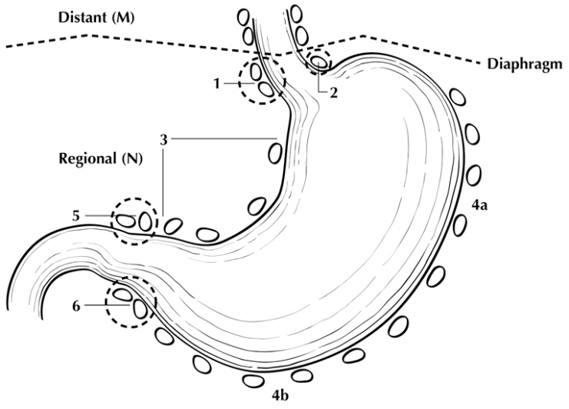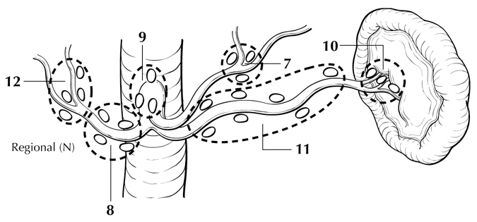
Figure 2. Regional lymph nodes of the stomach. Used with permission of the American Joint Committee on Cancer (AJCC), Chicago, IL. The original source for this material is the AJCC Cancer Staging Atlas (2006) edited by Greene et al¹⁴ and published by Springer Science and Business Media, LLC, www.springerlink.com.

- Perigastric along the greater curvature (including greater curvature, greater omental)
- Perigastric along the lesser curvature (including lesser curvature, lesser omental)
- Right and left paracardial (cardioesophageal)
- Suprapyloric (including gastroduodenal)
- Infrapyloric (including gastroepiploic)
- Left gastric artery
- Celiac artery
- Common hepatic artery
- Hepatoduodenal (along the proper hepatic artery, including portal)
- Splenic artery
- Splenic hilum

For gastrectomy specimens, at least 16 regional lymph nodes should be removed and assessed pathologically.

Involvement of other intra-abdominal lymph nodes, such as retropancreatic, pancreaticoduodenal, peripancreatic, superior mesenteric, middle colic, para-aortic, or retroperitoneal nodes, is classified as distant metastasis.¹

J. Pathologic Stage Classification
The TNM staging system for gastric carcinoma of the American Joint Committee on Cancer (AJCC) and the International Union Against Cancer (UICC) is recommended and shown below.¹

According to AJCC/UICC convention, the designation “T” refers to a primary tumor that has not been previously treated. The symbol “p” refers to the pathologic classification of the TNM, as opposed to the clinical classification, and is based on gross and microscopic examination. pT entails a resection of the primary tumor or biopsy adequate to evaluate the highest pT category, pN entails removal of nodes adequate to validate lymph node metastasis, and pM implies microscopic examination of distant lesions. Clinical classification (cTNM) is usually carried out by the referring physician before treatment during initial evaluation of the patient or when pathologic classification is not possible.

Pathologic staging is usually performed after surgical resection of the primary tumor. Pathologic staging depends on pathologic documentation of the anatomic extent of disease, whether or not the primary tumor has been completely removed. If a biopsied tumor is not resected for any reason (eg, when technically infeasible) and if the highest T and N categories or the M1 category of the tumor can be confirmed microscopically, the criteria for pathologic classification and staging have been satisfied without total removal of the primary cancer.

TNM Descriptors
For identification of special cases of TNM or pTNM classifications, the “m” suffix and “y,” “r,” and “a” prefixes are used. In the AJCC 8th edition, “y” affects the stage grouping.

The “m” suffix indicates the presence of multiple primary tumors in a single site and is recorded in parentheses: pT(m)NM.

The “y” prefix indicates those cases in which classification is performed during or after initial multimodality therapy (ie, neoadjuvant chemotherapy, radiation therapy, or both chemotherapy and radiation therapy). The cTNM or pTNM category is identified by a “y” prefix. The ycTNM or ypTNM categorizes the extent of tumor actually present at the time of that examination. The “y” categorization is not an estimate of tumor before multimodality therapy (ie, before initiation of neoadjuvant therapy).

The “r” prefix indicates a recurrent tumor when staged after a documented disease-free interval and is identified by the “r” prefix: rTNM.

The “a” prefix designates the stage determined at autopsy: aTNM.

Lymphovascular Invasion

Lymphovascular invasion (LVI) indicates whether microscopic lymphatic and/or vascular invasion is identified in the pathology report. LVI includes lymphatic invasion, vascular invasion, or lymph-vascular invasion. By AJCC/UICC convention, LVI does not affect the T category indicating local extent of tumor unless specifically included in the definition of a T category (also see Note G).

T Category Considerations (Figures 3-5)

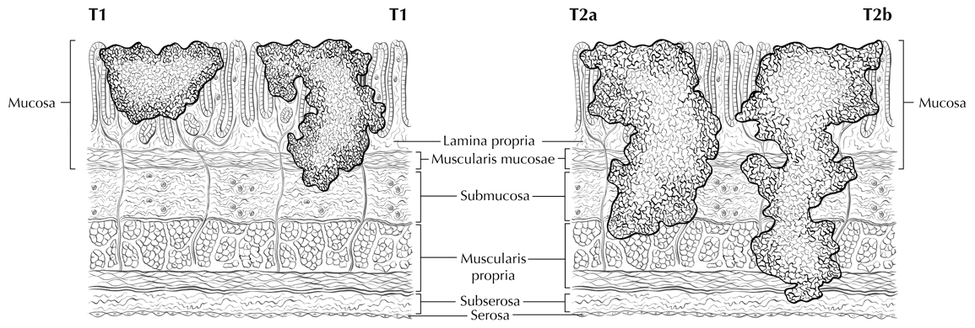
T2 T3
Figure 3. Definitions of T1, T2, and T3. Tumor invading the lamina propria is classified as T1a (left side in T1 illustration), whereas tumor invading the submucosa is classified as T1b (right side). T2 tumor invades the muscularis propria. T3 tumor invades the subserosal adipose tissue. Used with permission of the American Joint Committee on Cancer (AJCC), Chicago, IL. The original source for this material is the AJCC Cancer Staging Atlas (2006) edited by Greene et al¹⁴ and published by Springer Science and Business Media, LLC, www.springerlink.com.

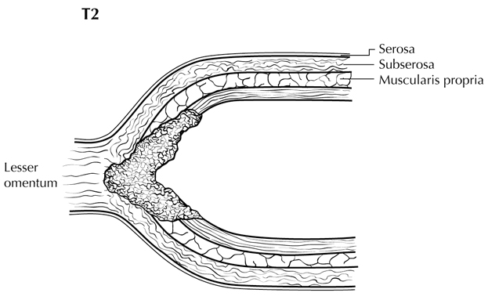  T3 | 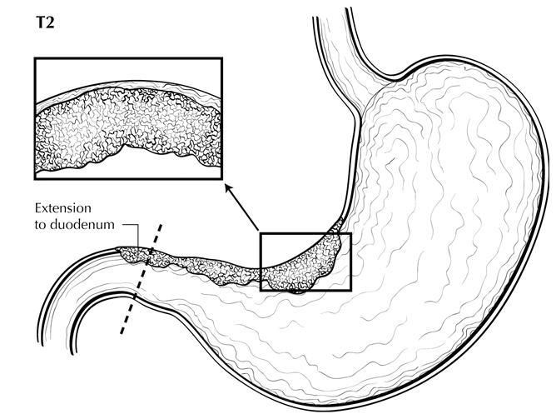  T3
Figure 4. T3 is defined as tumor that invades the subserosa. A T3 tumor may penetrate the muscularis propria with extension into the gastrocolic or gastrohepatic ligaments, or into the greater or lesser omentum (upper panel), without perforation of the visceral peritoneum covering these structures. Distal extension to duodenum (lower panel) does not affect T category. Used with permission of the American Joint Committee on Cancer (AJCC), Chicago, IL. The original source for this material is the AJCC Cancer Staging Atlas (2006) edited by Greene et al¹⁴ and published by Springer Science and Business Media, LLC, www.springerlink.com.

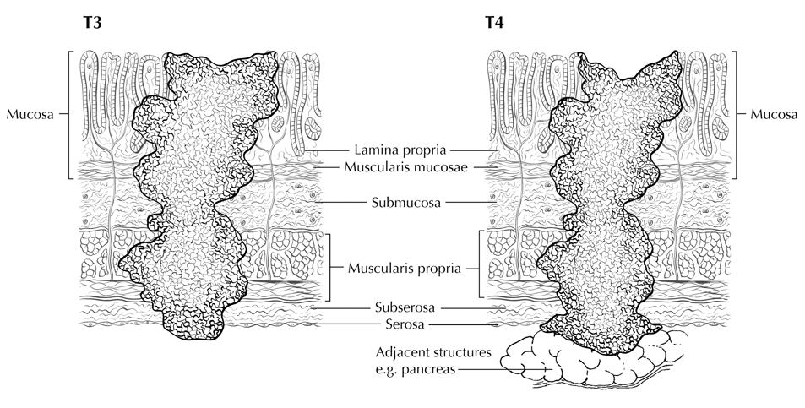
T4a
T4b
Figure 5. T4a tumor penetrates the serosa (visceral peritoneum) without invasion of adjacent structures, whereas T4b tumor invades adjacent structures, such as the pancreas (shown). Used with permission of the American Joint Committee on Cancer (AJCC), Chicago, IL. The original source for this material is the AJCC Cancer Staging Atlas (2006) edited by Greene et al¹⁴ and published by Springer Science and Business Media, LLC, www.springerlink.com.

N Category Considerations
A designation of N0 should be used if all examined lymph nodes are negative, regardless of the total number removed and examined.¹ Lymph nodes containing isolated tumor cells, defined as single tumor cells or small clusters of cells not more than 0.2 mm in diameter, are classified as pN0. However, in treated gastric cancers, positive lymph nodes are defined as having at least one focus of residual tumor cells in the lymph nodes regardless of size.

Metastatic tumor deposits in the subserosal fat adjacent to a gastric carcinoma, without evidence of residual lymph node tissue, are considered regional lymph node metastases for purposes of gastric cancer staging¹. Tumor deposits are defined as discrete tumor nodules within the lymph drainage area of the primary carcinoma without identifiable lymph node tissue or identifiable vascular or neural structure. Shape, contour, and size of the deposit are not considered in these designations. Nodules implanted on the peritoneal surface are considered distant metastases (M1).

Stage Groupings
A separate stage grouping is used to stage patients receiving preoperative therapy due to the fact that prognostic implication for ypTNM differs from those of equivalent pTNM.

Stage Groupings for pTNM
Stage 0 Tis N0 M0
Stage IA T1 N0 M0
Stage 1B T1 N1 M0
T2 N0 M0
Stage IIA T1 N2 M0
T2 N1 M0
T3 N0 M0
Stage IIB T1 N3a M0
T2 N2 M0
T3 N1 M0
T4a N0 M0
Stage IIIA T2 N3a M0
T3 N2 M0
T4a N1-2 M0
T4b N0 M0
Stage IIIB T1-2 N3b M0
T3 N3a M0
T4a N3a M0
T4b N1-2 M0
Stage IIIC T3 N3b M0
T4a N3b M0
T4b N3a or N3b M0
Stage IV Any T Any N M1

Stage groupings for ypTNM
Stage I T1-2 N0 M0
T1 N1 M0
Stage II T1 N2-3 M0
T2 N1-2 M0
T3 N0-1 M0
T4a N0 M0
Stage III T2 N3 M0
T3 N2-3 M0
T4a N1-3 M0
T4b Any N M0
Stage IV Any T Any N M1

K. Other Findings
One of the most important risk factors for development of gastric carcinoma is long-standing infection with Helicobacter pylori, which leads to chronic gastritis and mucosal atrophy with intestinal metaplasia; autoimmune atrophic chronic gastritis, also a chronic inflammatory condition, is also associated with increased risk.¹² Occasionally, gastric carcinoma arises in a preexisting gastric polyp, most commonly large hyperplastic polyps in the setting of atrophic gastritis. Previous gastric surgery, such as Bilroth I or Bilroth II procedures for both benign and malignant indications, predisposes to the development of carcinoma in the remnant stomach; such tumors typically arise approximately 25 years after surgery for benign diseases.¹³

References
1. Amin MB, Edge SB, Greene FL, et al, eds. AJCC Cancer Staging Manual. 8th ed. New York, NY: Springer; 2017.
2. Bosman FT, Carreiro F, Ralph H. Hruban, Teise N, eds. World Health Organization Classification of Tumours of the DIgestive System. 4th ed. Geneva, Switzerland: WHO Press; 2010.
3. Talamonti MS, Kim SP, Yao KA, et al. Surgical outcomes of patients with gastric carcinoma: the importance of primary tumor location and microvessel invasion. Surgery. Oct 2003;134(4):720-727; discussion 727-729.
4. Lauren P. The two histological main types of gastric carcinoma. Acta Pathol Microbiol Scand. 1965;64:31-49.
5. Luebke T, Baldus SE, Grass G, et al. Histological grading in gastric cancer by Ming classification: correlation with histopathological subtypes, metastasis, and prognosis. World J Surg. 2005;29(11):1422-1427; discussion 1428.
6. Inoue K, Nakane Y, Michiura T, et al. Histopathological grading does not affect survival after R0 surgery for gastric cancer. Eur J Surg Oncol. 2002;28(6):633-636.
7. Ryan R, Gibbons D, Hyland JMP, et al. Pathological response following long-course neoadjuvant chemoradiotherapy for locally advanced rectal cancer. Histopathology. 2005;47:141-146.
8. Mansour JC, Tang L, Shah M, et al. Does graded histologic response after neoadjuvant chemotherapy predict survival for completely resected gastric cancer? Ann Surg Oncol. 2007;14(12):3412-3418.
9. Rohatgi PR, Mansfield PF, Crane CH, et al. Surgical pathology stage by American Joint Commission on Cancer criteria predicts patient survival after preoperative chemoradiation for localized gastric carcinoma. Cancer. 2006;107(7):1475-1482.
10. Fotia G, Marrelli D, De Stefano A, Pinto E, Roviello F. Factors influencing outcome in gastric cancer involving muscularis and subserosal layer. Eur J Surg Oncol. 2004;30(9):930-934.
11. An JY, Baik YH, Choi MG, Noh JH, Sohn TS, Kim S. Predictive factors for lymph node metastasis in early gastric cancer with submucosal invasion: analysis of a single institutional experience. Ann Surg. 2007;246(5):749-753.
12. Kelley JR, Duggan JM. Gastric cancer epidemiology and risk factors. J Clin Epidemiol. 2003;56(1):1-9.
13. An JY, Choi MG, Noh JH, Sohn TS, Kim S. The outcome of patients with remnant primary gastric cancer compared with those having upper one-third gastric cancer. Am J Surg. 2007;194(2):143-147.
14. Greene FL, Compton, CC, Fritz AG, et al, eds. AJCC Cancer Staging Atlas. New York: Springer; 2006.

