Supplement to the HQIP - BX series for 2013-A
Nuclear Bubbling - Probable cause(s)/Potential remedies
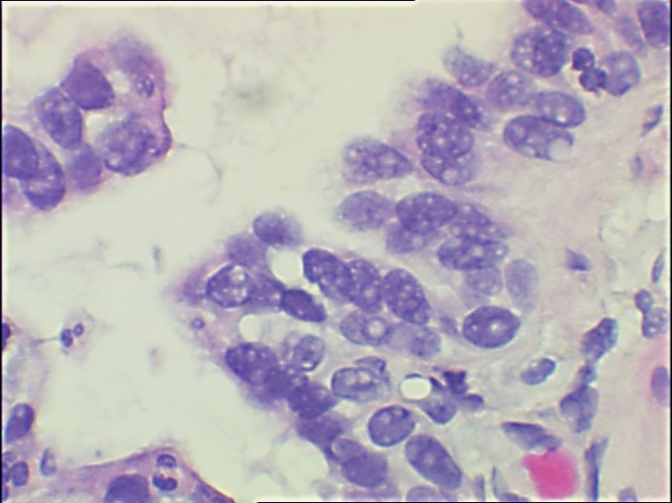
One of the most notable artifacts observed in the grading of the 2013 HQIP BX-series were slides containing nuclear bubbling artifact. (pictured below) Of particular concern was the number of prostate biopsies (21%, 12/57) containing the artifact, followed closely by bladder biopsies (19%, 10/52) and then colon biopsies (12%, 13/110), esophagus biopsies (12%, 13/109), skin shave biopsies (12%, 10/82), and skin punch biopsies (11%, 9/83).
Nuclear bubbling can seriously compromise the pathologic diagnosis. Several authors have suggested that the use of 10% neutral buffered formalin (NBF) alone causes nuclear distortion but Dapson attributes it to the specimen not being completely fixed in NBF before dehydration has begun.^{1,2,3} There are some other rational explanations and well known facts that may help explain its cause.
First, it is generally recognized that NBF is a poor fixative for nuclei. It has little, if any, reaction with nucleic acids below 45°C. ^{4,5} Second, although NFB may have had time to penetrate small biopsies or needle cores in a relatively short time, the tissues are still under-fixed in NBF, as the nuclear proteins have not developed stabilizing cross-links with the aldehydes from the NBF. The duration of fixation is very important. NBF needs a minimum of 6-8 hours to act before the processing schedule is begun.⁶ Complete fixation is not achieved in less than 24 hours. Adequate fixation time is required to maintain proper relationships of all tissue structures otherwise, fixation will continue to take place by alcohol in subsequent processing steps. The emphasis on turn-around-time has seriously compromised the laboratory’s ability to devote adequate time to proper fixation. All of these factors contribute to nuclear bubbling.
Histotechnologists have observed that drying the slides immediately after sectioning in an oven or slide dryer set above 58-60°C, without allowing them to drain properly, can cause nuclear bubbling. The water between the section and slide is overheated, causing the nuclei to bubble. In a 1990 article, published in the Journal of Histotechnology, the authors introduced a modified draining/drying protocol and eliminated all nuclear bubbling artifact. ⁷ The practice of affixing a freshly cut section with a hot plate or drying pad should be avoided, as this direct heat process can have the same effect of overheating the water trapped between the section and the slide.
All of these factors contribute to nuclear bubbling.
Below are some additional photographs displaying nuclear bubbling artifact from the 2013-A HQIP - BX grading session.
References:
1. Banks PM. Technical aspects of specimen preparation and special studies. In: Jaffe ES, ed. Surgical Pathology of the Lymph Nodes and Related Organs. Philadelphia, PA: WB Saunders Co: 1985
2. Fox CH, Johnson FB, Whiting J, Roller PP. Formaldehyde Fixation. J Histochem Cytochem 1985:33:8.
3. Dapson RW. Fixation for the 1990's: A Review of needs and accomplishments. Biotech Histochem 1993:68:75.
4. Kiernan JA. Histological & Histochemical Methods: Theory & Practice. New York,NY: Pergamon Press, 1990.
5. Baker JR. Principles of Biological Microtechnique. London: Methuen & Co. Ltd.: 1958.
6. Carson FL, Hladik C. Histotechnology: A Self-Instructional Text, 3rd ed. Chicago, IL: ASCP Press: 2009; 5-6.
7. Sontoianni R, Hammami A. Nuclear Bubbling: An Overlooked Artifact. J Histotechnol 1990:13; 135-136.

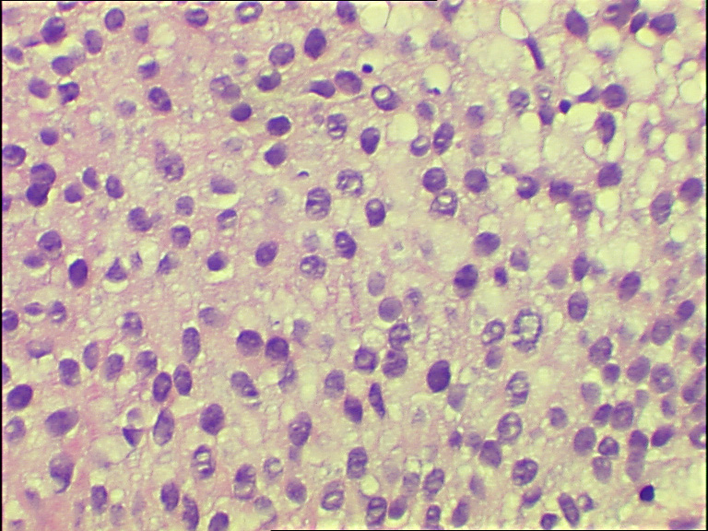
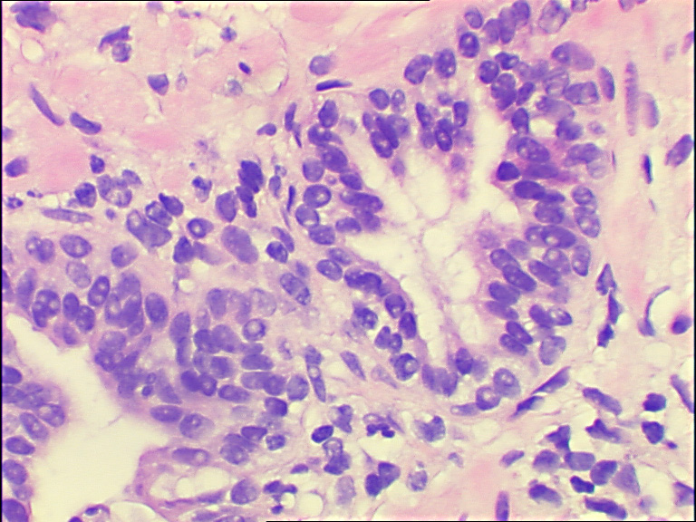
Prostate biopsy Bladder biopsy

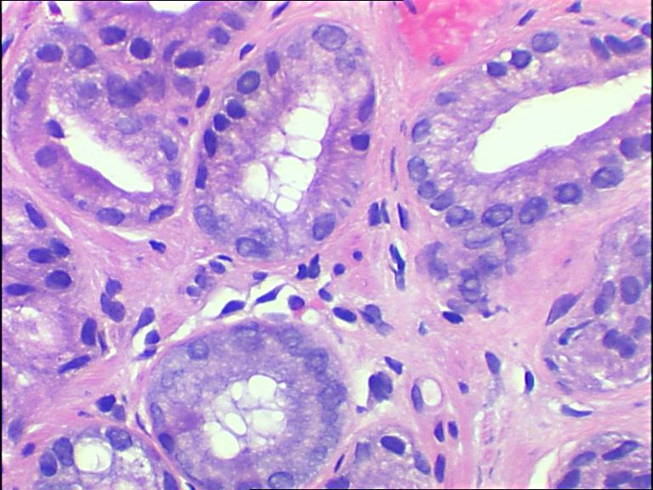
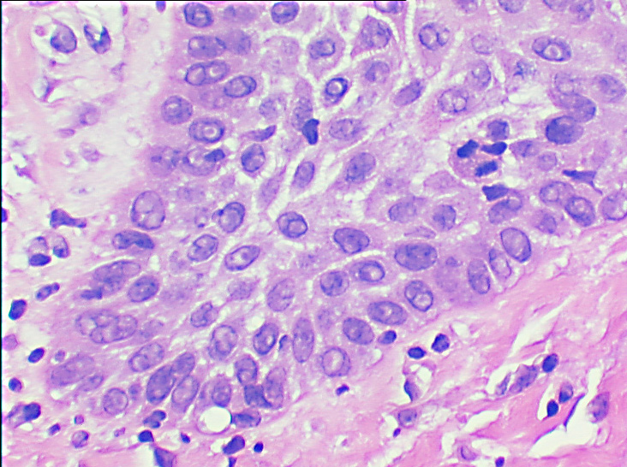
Skin shave biopsy Stomach biopsy

